John Hende

I started out in the 1380s as a draper, which means that I sold cloth. I married my first wife, Isabella, in 1368. She came from a famous family of drapers and I was probably an apprentice to her father when I met her and would have spent a long time learning the trade from him. When I got married, we got a shop with a living space above it in Candlewick Street in London.

It was quite a comfortable life, but I dreamt of more. I was good at my job and a shrewd businessman, so I was becoming very wealthy. I wanted more prestige, so I got involved in local government. First I was an alderman and then a sheriff – both were important jobs that enforced laws. At the same time, I used the money I had made selling cloth to buy land in Kent and Essex. Everyone knows that this is the only way if you want to gain a better social standing. I bought the first of what would become eight Essex manors, Mascallsbury in White Roding, in around 1370. Sadly, my wife died, but I was able to make another good match to Katherine Baynard. She was a widow with lots of land in Essex and was from a well-established gentry family. I’d gone from being a shopkeeper, to a wealthy merchant, to being on the edges of the nobility!

I knew that I really wanted to buy a new manor called Bradwell-juxta-Coggeshall. This was frustratingly complicated, however. I had the money – they should have just let me have it! The King’s escheator in the area was called John Ewell, and it was his job to sort out what happened to land when someone died. We did not get on. On 12 February 1381, I had to go to court and bring with me people who promised that I would behave and follow the rules, called ‘mainpernors’. My friend, the writer Geoffrey Chaucer, came along to support me. I had to promise not to interfere with John Ewell or his servants, and if I did, my friends and I would all have to pay huge sums of money. I was definitely going to stay away from him, as I didn’t want to have to pay £500 – a fortune!

However, everything changed in June 1381, when the rebellion broke out. Local rebels also hated John Well for being a poll tax collector, and killed him. I saw my opportunity! I sent my men to go and take the manor of Bradwell-juxta-Coggeshall from the rebels… they may have gotten a little carried away and took the money that they found, and they were even accused of breaking into the dovecote and taking the doves. I thought that perhaps we had gotten away with it but, on 29 September, the manor was taken back to be owned by the Crown and I had to go in front of the King’s Bench to explain myself.

I was very worried – what if they thought I was a rebel? I have always considered myself very loyal to the Crown, I just also always wanted that manor… I entered a plea and offered to pay a fine to show how sorry I was. Luckily, they believed me and I was let off, and finally, by 1385, I managed to get the rights to the manor anyway. In the meantime, as I was sheriff, I heard the cases of other rebels and made sure that they were brought to justice. I was always loyal to the King; I wasn’t a real rebel, you understand – just someone who saw a good opportunity, so I was very happy to make sure that real rebels were punished.
After 1381, I became extremely wealthy. I was a major and later became the leading money-lender to King Henry IV. When I died in 1418, I was able to leave thousands of pounds in cash to my wife and sons, as well as income from my estates. In order to provide for my soul in heaven, I left lots of money to the church in Bradwell and was buried there.

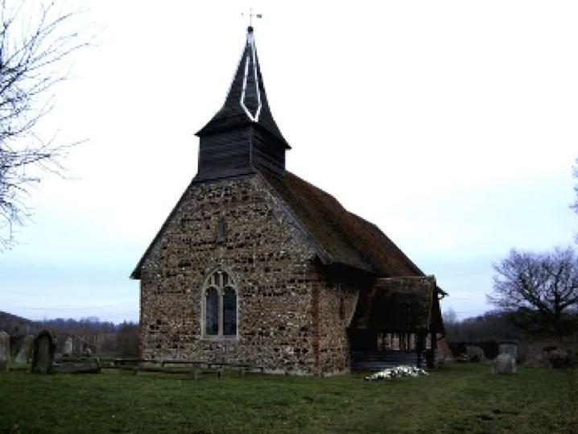Holy Trinity Church, Bradwell Juxta Coggeshall, Essex

References

Based on: www.1381.online/people_and_places/?story_id=42

